Q1: Draw a labeled diagram of a desktop PC, clearly marking the motherboard, CPU, RAM, GPU, and both HDD and SSD storage components.

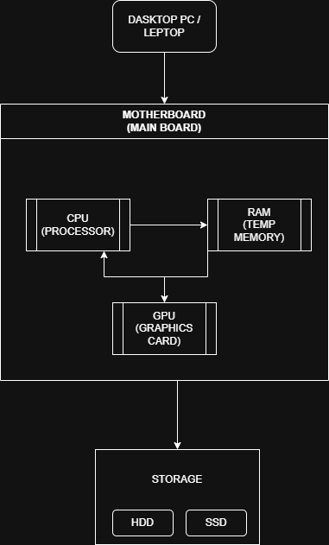

Q2: Create a comparison table showing the main differences between HDD and SSD storage in terms of speed, durability, and typical use cases. Think about which one is faster, which is more shock-resistant, and where you would usually find each type (laptop, gaming PC, etc.)

HDD (Hard Disk Drive) | SSD (Solid State Drive)
Uses spinning magnetic disks to store data | Uses flash memory chips to store data
Less durable because it has moving mechanical parts | More durable because it has no moving parts and is shock-resistant
Produces noise due to spinning disks | Silent operation because there are no moving parts
Large file storage, backups, desktop PCs, CCTV systems | Operating system, gaming PCs, laptops, high-performance computers, video editing
Consumes more power | Consumes less power, improving battery life

Q3: Write a short explanation (2-3 sentences each) describing the role of the CPU, RAM, and GPU in running a game like PUBG or Free Fire on a PC.

1. CPU (Central Processing Unit)
- The CPU is the brain of the computer.
- It processes all game instructions and player inputs.
- It controls game logic, AI, and physics during gameplay.

2. RAM (Random Access Memory)
- RAM temporarily stores game data while the game is running.
- It helps the game load faster and run smoothly.
- More RAM reduces lag and improves multitasking.

3. GPU (Graphics Processing Unit)
- The GPU renders game graphics, textures, and visual effects.
- It provides smooth gameplay with higher FPS (Frames Per Second).
- It improves the overall visual quality of games like PUBG and Free Fire.

Q4: Imagine you want to upgrade your PC to run the latest version of FIFA smoothly. List which hardware components you would consider upgrading and explain why for each.

CPU (Processor) | A faster CPU processes game logic, AI, and player actions more efficiently, resulting in smoother gameplay.
GPU (Graphics Card) | A better GPU improves graphics quality, increases FPS (Frames Per Second), and delivers a smoother gaming experience.
RAM | More RAM allows the game to run smoothly, reduces lag, and improves overall system performance while gaming.
SSD (Solid State Drive) | An SSD speeds up game loading times, reduces waiting time, and helps the operating system and game start faster.

